Star chemistry
Key words
Constellation: this is a group of stars making a shape in the sky when joined by lines we imagine. Many constellations are named after animals or people from ancient history, eg Orion is the Hunter in Greek history. Stars in the constellations are not the same distance away – they only seem to be on a flat surface because the distances are so huge that our eyes cannot tell any differences between them.
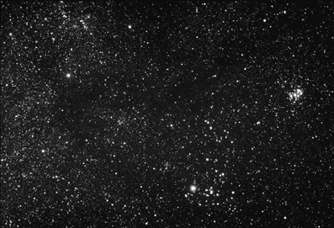 | 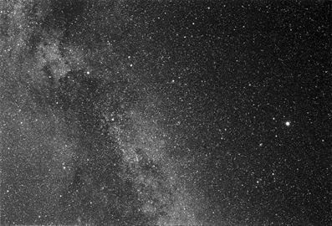
Taurus  Reproduced with kind permission from Till Credner, AlltheSky.com. | Cygnus and Lyra  Reproduced with kind permission from Till Credner, AlltheSky.com.
Big Bang: the universe is thought to have started with a huge explosion, called the Big Bang. The explosion spread matter out from a tiny volume into a huge one.
Nebula: This is an area of space where we find dust, chemical elements and stars. Their beauty is caused by the reflection of starlight on dust and other elements in the area. Nebulae are very large - the Horsehead Nebula is 2.5 x 10¹³ km from top to bottom (this is equivalent to the distance 625 million times around the Earth!). The Orion Nebula can be seen with the
naked eye. The plural (that is, if there is more than one) of nebula is 'nebulae'.
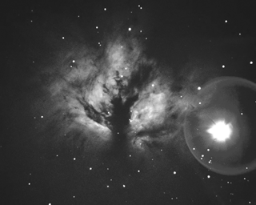
  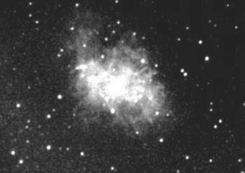 | 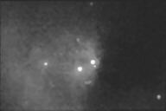
  The crab nebula | The diffuse nebula
  Reproduced with kind permission from John Rummel, Madison Metropolitan School District, Madison Wisconsin.
The flame nebula
Reproduced with kind permission from Jason Ware, www.galaxyphoto.com
(accessed November 2003).
continued on next page



Star chemistry
continued from previous page
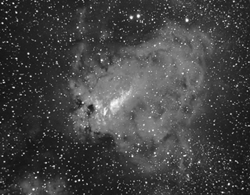 | 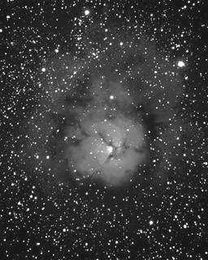 | 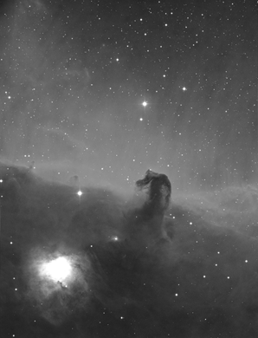
The swan nebula  Reproduced with kind permission from Jason Ware, www.galaxyphoto.com (accessed November 2003). | The trifid nebula  Reproduced with kind permission from Jason Ware, www.galaxyphoto.com (accessed November 2003). | The horsehead nebula  ©1979-2002, Anglo-Australian Observatory photographed by  David Malin.

Spectral colours: are the colours that are seen in the photos. The word spectral is taken from the word 'spectrum' (see below). Spectral colours are made when light from nearby stars passes through the substances. Light of some wavelengths is absorbed. The colours we see are reflected light. Hydrogen atoms, for example, reflect red light in the visible region of the
electromagnetic spectrum.
Spectrum: this word is used in science to mean the spread or range of energies or values. Scientists talk about the electromagnetic spectrum, or EMS, meaning the types of electromagnetic radiation which differ only by their wavelength and frequency, eg – X-rays, infrared, radiowaves, and gamma rays are all part of the EMS. Our eyes can see part of the EMS – this is called the 'visible' region. The EMS is arranged in wavelength order, usually from shortest to longest (left to right) in a diagram. The word spectrum itself comes from a Latin word, 'specere', which means 'to look at'.
Telescope: the word comes from Greek, 'skopos' which means 'one who watches'.

